EXP NO 6: DEMONSTRATE VIRTUALIZATION BY INSTALLING TYPE-2
HYPERVISOR IN YOUR DEVICE, CREATE AND CONFIGURE VM IMAGE
WITH A HOST OPERATING SYSTEM (EITHER WINDOWS/LINUX).
DATE:
AIM:
To demonstrate virtualization by installing type-2 hypervisor in your device, create and configure VM
image with a host operating system (either windows/linux).
PROCEDURE:
STEP 1:Dowload VMware workstation and installed as type 2hypervisor.
STEP2:Dowload ubuntu or tiny OS as iso image file.
STEP 3: In VMware workstation->create new VM.
STEP 4: Do the basic configuration settings.
STEP 5: Created tiny OS virtual machine.
STEP 6: Launch the VM.
IMPLEMENTATION:
STEP 1:DOWLOAD VMWARE WORKSTATIONAND INSTALLED AS TYPE 2HYPERVISOR
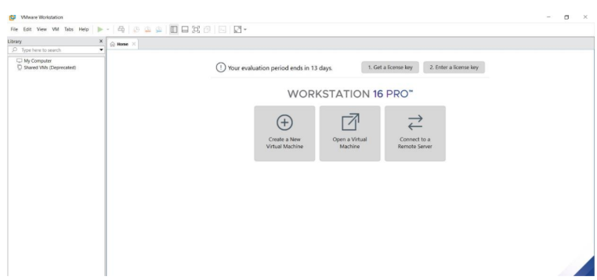
STEP2: DOWLOAD UBUNTU OR TINY OS AS ISO IMAGE FILE
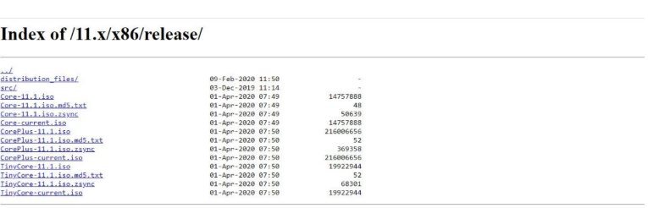
STEP 3: IN VMWARE WORKSTATION->CREATE NEW VM
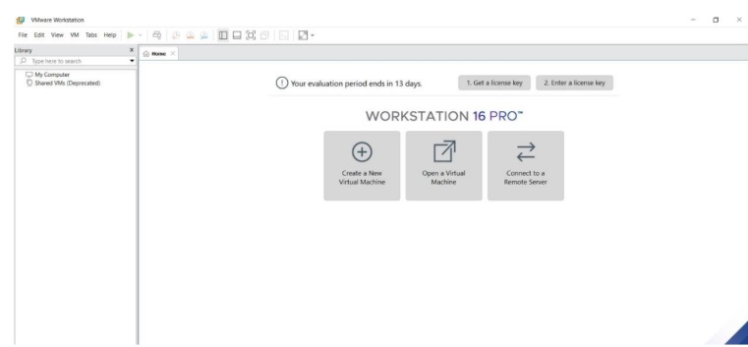
STEP 4: DO THE BASIC CONFIGURATION SETTINGS.
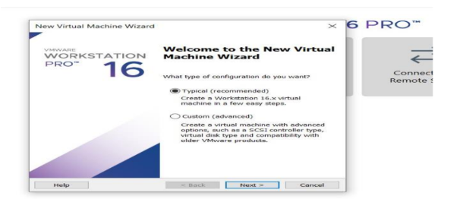
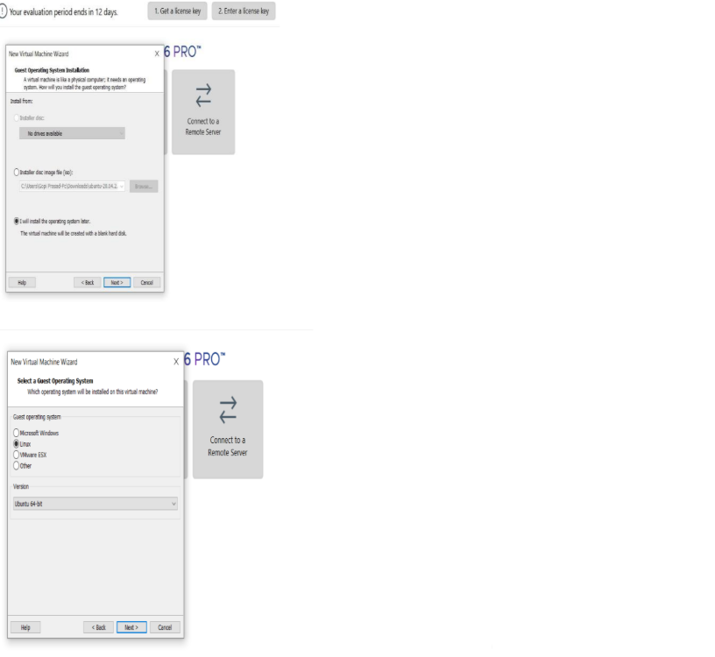
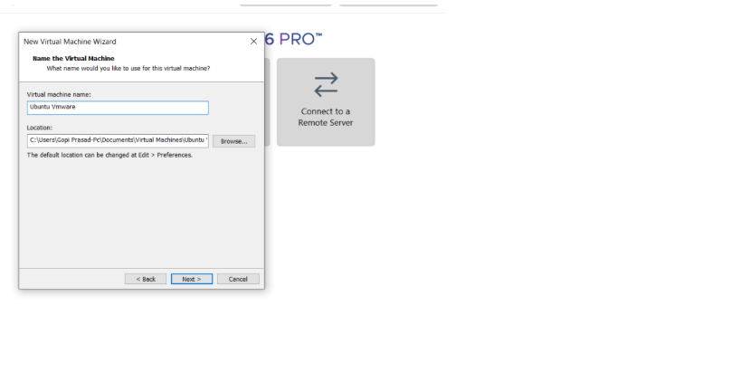
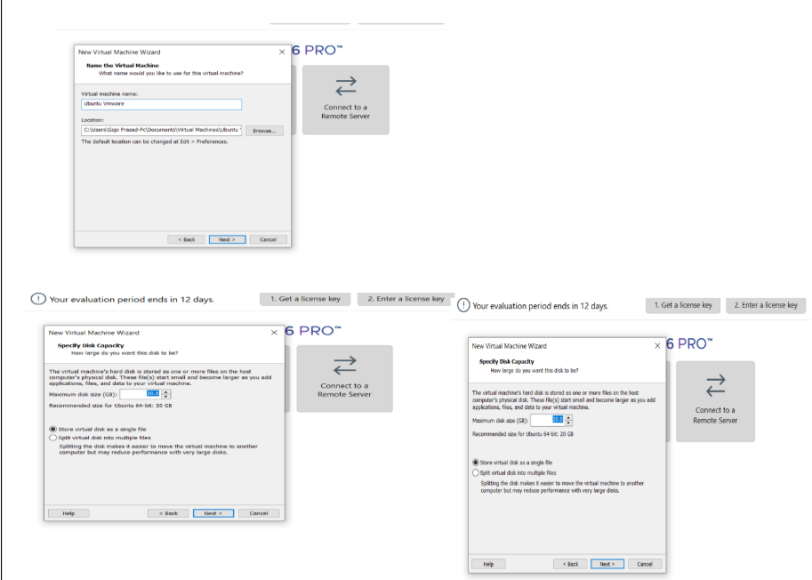
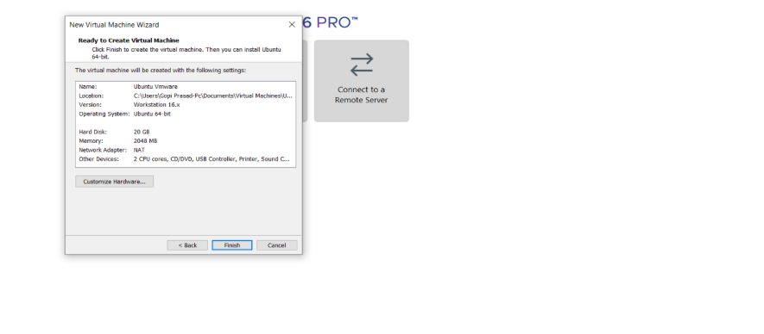
STEP 5: CREATED TINYOS VIRTUAL MACHINE
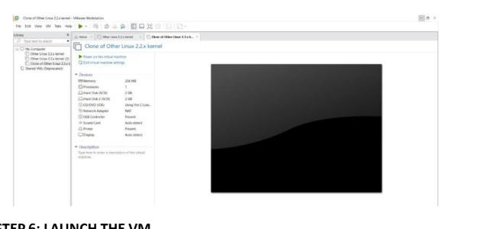
STEP 6: LAUNCH THE VM
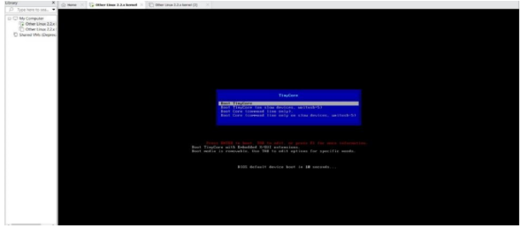
EXPNO 7: CREATE A VIRTUAL MACHINE WITH 1 CPU, 2GB RAM AND
15GB STORAGE DISK USING A TYPE 2 VIRTUALIZATION SOFTWARE.
DATE:
AIM:
To create a virtual machine with 1 cpu, 2gb ram and 15gbstorage disk using a type
2 virtualization software.
PROCEDURE:
STEP 1:Dowload VMware workstation and installed as type 2hypervisor.
STEP2:Dowload ubuntu or tiny OS as iso image file.
STEP 3: In VMware workstation->create new VM.
STEP 4: Do the basic configuration settings.
STEP 5: Created tiny OS virtual machine.
STEP 6: Launch the VM.
IMPLEMENTATION:
STEP 1:DOWLOAD VMWARE WORKSTATIONAND INSTALLED AS TYPE 2HYPERVISOR
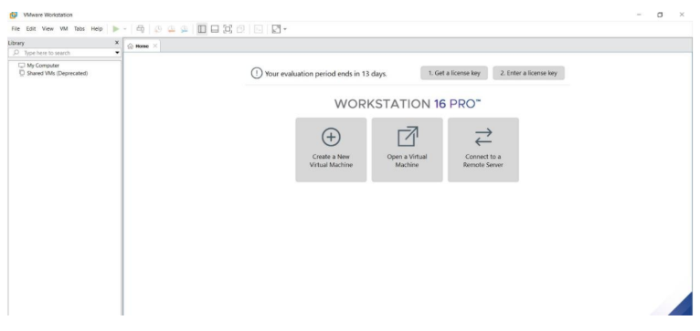
STEP2: DOWLOAD UBUNTU OR TINY OS AS ISO IMAGE FILE
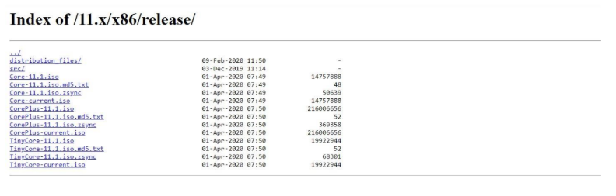
STEP 3: IN VMWARE WORKSTATION->CREATE NEW VM
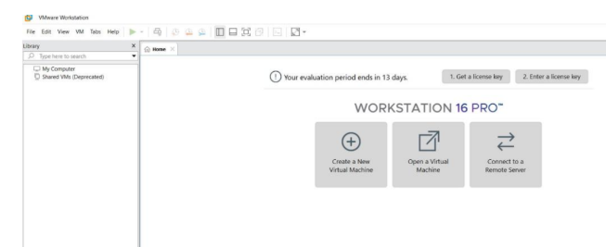
STEP 4: DO THE BASIC CONFIGURATION SETTINGS.
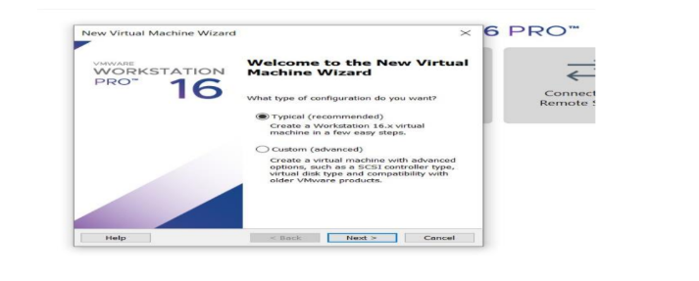
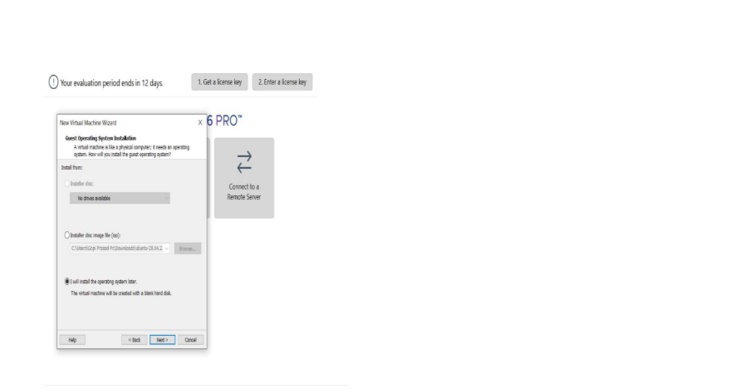
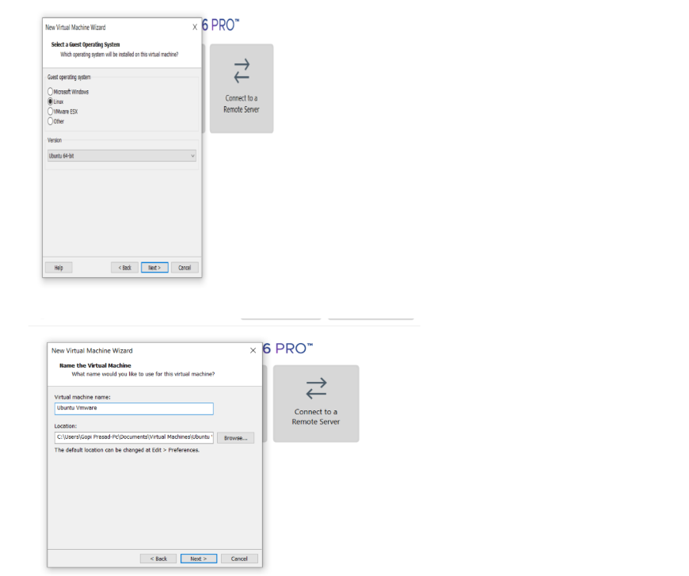
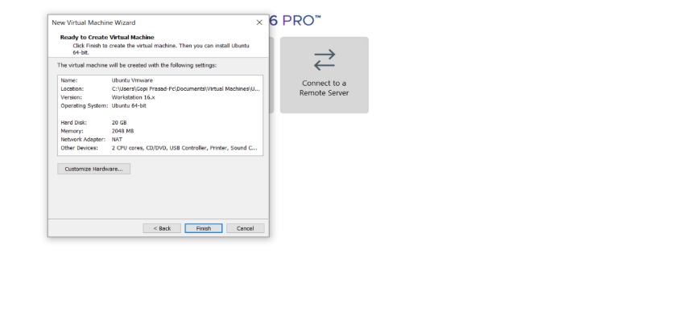

STEP 5: CREATED TINYOS VIRTUAL MACHINE
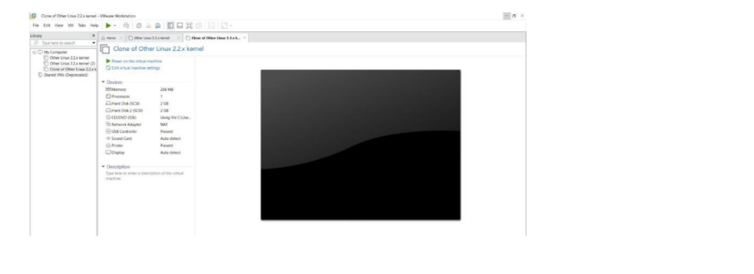
EXP 8: CREATE AVIRTUAL HARD DISK AND ALLOCATE THE STORAGEUSING VM WARE
WORKSTATION.
DATE:
AIM:
To create a virtual hard disk and allocate the storage using vm ware workstation
PROCEDURE:
STEP 1:GOTO VM WARE WORKSTATION.
STEP2: RIGHT CLICK THE VM AND GOTO THE SETTINGS.
STEP 3: ADD HARDWARE WIZARD AND SELECT SCSI AND CLICK NEXT.
STEP 4: CREATE NEW VIRTUAL DISK.
STEP 5: SELCT THE DISK SIZE AS 2.0. AND SELCT SPLIT VIRTUAL DISK INTOMULTIFILES.
STEP 6: GIVE NAME AND CLICK THE FINISH.

IMPLEMENTATION:
STEP 1:GOTO VM WARE WORKSTATION
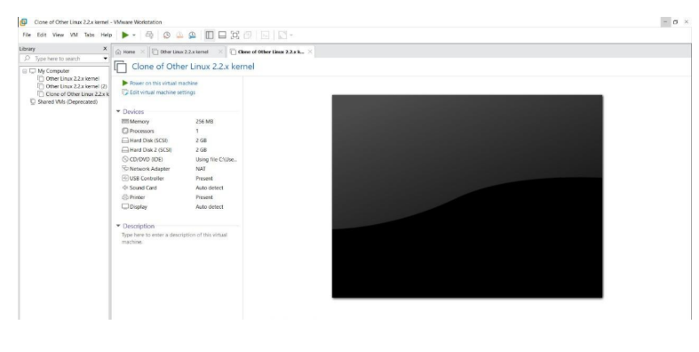
STEP2: RIGHT CLICK THE VM AND GOTO THE SETTINGS
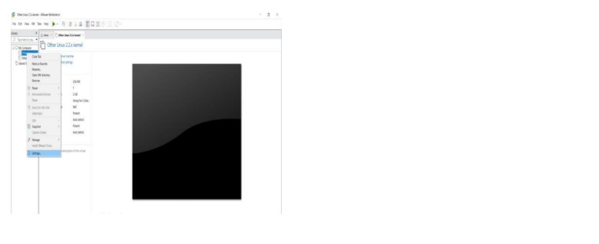
STEP 3: ADD HARDWARE WIZARD AND SELECT SCSI AND CLICK NEXT
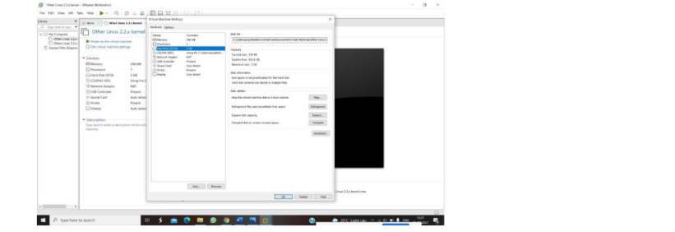
STEP 4: CREATE NEW VIRTUAL DISK
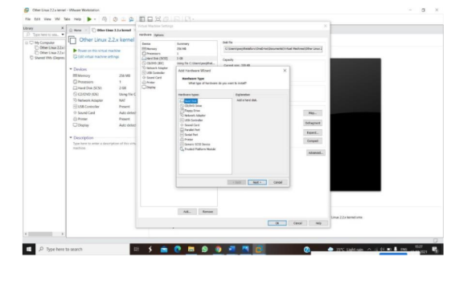
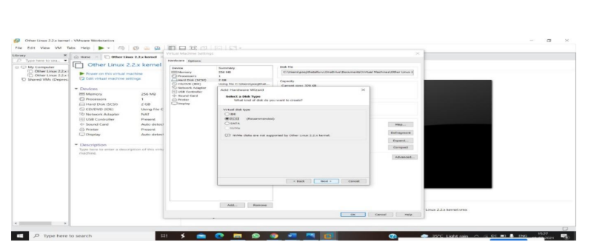
STEP 5: SELCT THE DISK SIZE AS 2.0. AND SELCT SPLIT VIRTUAL DISK INTOMULTIFILES.
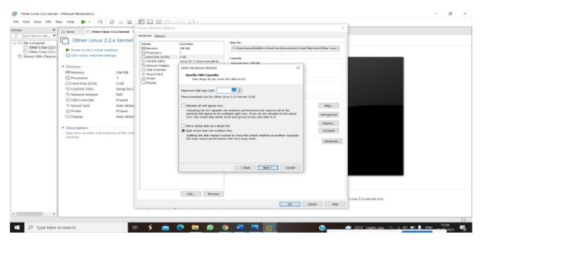
STEP 6: GIVE NAME AND CLICK THE FINISH 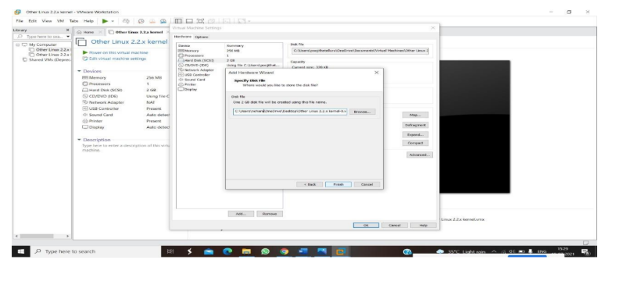

EXPNO 9: CREATE A SNAPSHOT OF A VM AND TEST IT BY LOADING THE PREVIOUS
VERSION/CLONED VM
DATE:
AIM:
To create a snapshot of a vm and test it by loading the previous version/cloned vm
PROCEDURE:
STEP 1: GOTO VMWARE WORKSTATION.
STEP 2: CREATE FILES ON DESKTOP.
STEP 3: CLICK ON VM AND SELECTS SNAPSHOT-> TAKE SNAPSHOT.
STEP 4: SNAPSHOT IS BEING DONE
IMPLEMENTATION:
STEP 1: GOTO VMWARE WORKSTATION
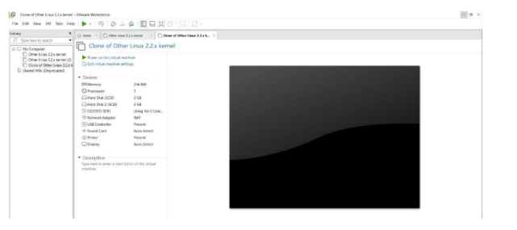
STEP 2: CREATE FILES ON DESKTOP
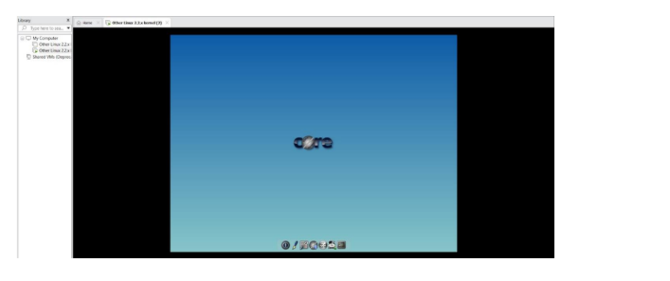
STEP 3: CLICK ON VM AND SELECTS SNAPSHOT-> TAKE SNAPSHOT.
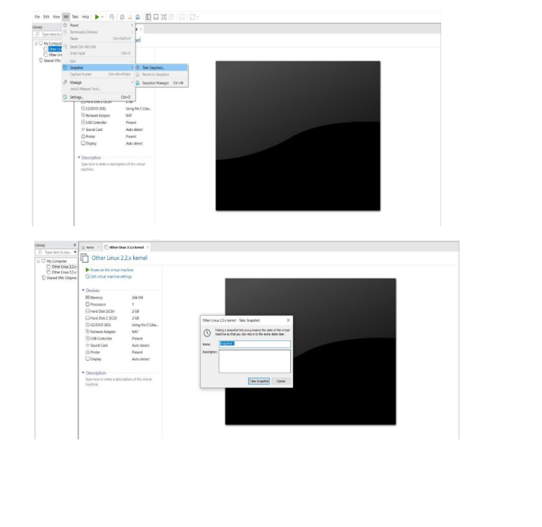
STEP 4: SNAPSHOT IS BEING
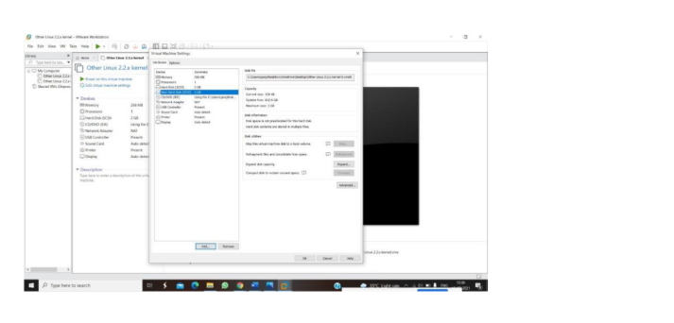
EXPNO 10: CREATE A CLONING OF A VM AND TEST IT BY LOADING
THE PREVIOUS VERSION/CLONED VM.
DATE:
AIM:
To create a cloning of a vm and test it by loading the previous version/cloned vm.
PROCEDURE:
STEP 1: GO TO VM AND GOTO MANAGE AND CLICK CLONE
STEP 2: CLICK CLONE
STEP 3: SELECT THE FULL CLONE
STEP 4: AFTER CLONE AGAIN OR VM IS OPENED.
IMPLEMENTATION:
CLONING OFA VM
STEP 1: GO TO VM AND GOTO MANAGE AND CLICK CLONE
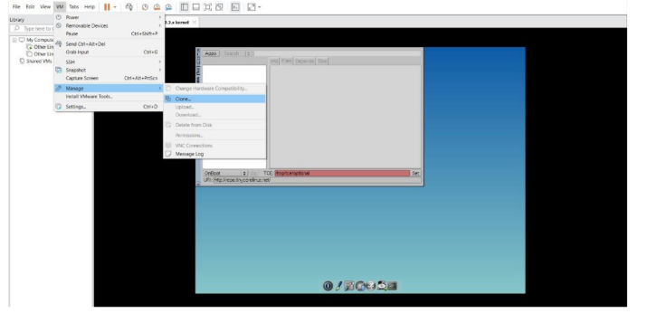
STEP 2: CLICK CLONE
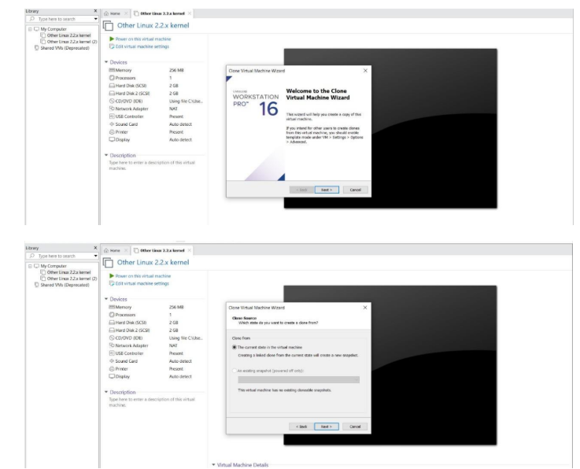
STEP 3: SELECT THE FULL CLONE
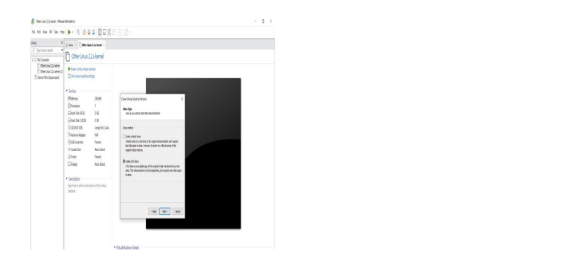
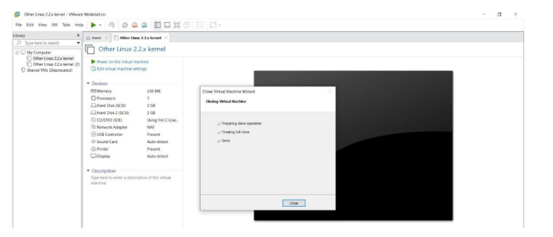
STEP 4: AFTER CLONE AGAIN OR VM IS OPENED.
